|  |  |
| --- | --- |
|  | **Year 11 General Biology**  **Task 3 – Classification and Working as a biologist Test** |

|  |  |  |  |
| --- | --- | --- | --- |
| **Name:** | **Teacher:** | **Date:** | **Score: /67** |

**Assessment type:** Test

**Conditions**

Time for the task: 55 minutes

**Task weighting** – 5%

Total 67 marks

______________________________________________________________________________

**Part A: Multiple-choice (15 marks)**

This section has 15 questions. Answer all questions by writing the letter corresponding to the correct answer in the box provided.

______________________________________________________________________________

1. When you classify, you place things in _______________.
2. Genus
3. Order
4. Family
5. Groups
6. Humans belong to ________________ kingdom.
7. Plantae
8. Animalia
9. Fungi
10. Protist
11. The genus name for humans is ___________________.
12. On very hot days it licks its forearms to allow them to cool by evaporation
13. It hides in caves or under trees on hot days
14. It digs to find water in dry creek beds
15. It has a long heavy tail that balances its body when it hops
16. The current system of naming a species uses which of the following two levels of classification?
17. Phylum and class
18. Order and class
19. Genus and family
20. Genus and species
21. Which of these combinations best describes members of the animal kingdom?
22. Specialised cell organelles, rigid cell wall, heterotrophs
23. No specialized cell organelles, rigid cell wall, heterotrophs
24. Multicellular, flexible cell membrane, heterotrophs
25. Heterotrophs, flexible cell membrane, asexual reproduction
26. The kingdom of the eukaryotes not classified as plants, animals or fungi is known as:
27. Archaea
28. Protista
29. Prokaryote
30. Plantae
31. A multicellular, autotrophic, eukaryotic organism would be classified as:
32. A protist
33. A plant
34. A fungus
35. A bacterium
36. Which of the following lists the correct classification levels, from largest group to smallest?
37. Phylum, order, class, genus, family
38. Order, phylum, class, family, genus
39. Phylum, class, order, family, genus
40. Class, phylum, order, family, genus
41. Scientists use a dichotomous key to:
42. Locate an organism and its niche
43. Divide a kingdom into smaller groups
44. Identify an organism
45. ‘Unlock’ the relationships between two organisms
46. The common housefly belongs to all of the following levels of classification. If you had access to textbooks, which of the following levels would give you the most specific information about this species?
47. Order Diptera
48. Genus Musca
49. Class Hexapoda
50. Family Muscidae
51. For two animals to be of the same species they must:
52. Look very similar
53. Be able to mate
54. Come from the same area
55. Produce fertile offspring
56. Consider the following table which contains some blank spaces.

|  |  |  |  |  |
| --- | --- | --- | --- | --- |
|  | **Organism** | | | |
| **A** | **B** | **C** | **D** |
| **Phylum** | Arthropoda |  |  |  |
| **Class** | Insecta |  |  |  |
| **Order** | Coleoptera | Coleoptera |  |  |
| **Family** | Buprestidae | Scarabaeidae |  | Buprestidae |
| **Genus** | *Melobasis* | *Heteranychus* | *Melobasis* | *Stigmodera* |
| **Species** | *metallica* | *santaechelenae* | *sexplagiata* | *gratiosa* |

Which organism is most closely related to organism D?

1. A
2. B
3. C
4. All are equally related
5. The possum and the koala are classified together because they are:
6. Herbivorous
7. Pouched mammals
8. Arboreal
9. Australian
10. Use the dichotomous key below to identify the bandicoot illustrated.

1. Pig-footed bandicoot
2. Long-nosed bandicoot
3. Short-nosed bandicoot
4. Rufescent bandicoot
5. Below is a key to identify gliding possums of the east of Australia.

The glider illustrated above is most likely a

1. Pygmy glider
2. Greater glider
3. Sugar glider
4. Yellow-bellied glider

**End of Part A**

**Part B: Short answer (42 marks)**

Answer all questions in the spaces provided.

______________________________________________________________________________

26. (a) Examine the diagram of the heart given below and complete the table.



|  |  |  |
| --- | --- | --- |
| **Structure** | **Name of structure** | **Function** |
| X |  |  |
| W |  |  |
| V |  |  |

(3 marks)

1. Explain why chamber Z has a thicker wall than the chamber on the opposite side of the heart.

__________________________________________________________________________________

(1 mark)

1. Describe where the blood goes and what happens to it once it exits the right ventricle up until the point it enters the left atrium.

__________________________________________________________________________________

__________________________________________________________________________________

__________________________________________________________________________________

__________________________________________________________________________________

__________________________________________________________________________________

__________________________________________________________________________________

__________________________________________________________________________________

__________________________________________________________________________________

__________________________________________________________________________________

(4 marks)

1. Explain the function of the following components in blood:

Leucocytes: ________________________________________________________________________

Plasma: ___________________________________________________________________________

(2 marks)

27. (a) Examine the following diagram and fill out the table that follows.

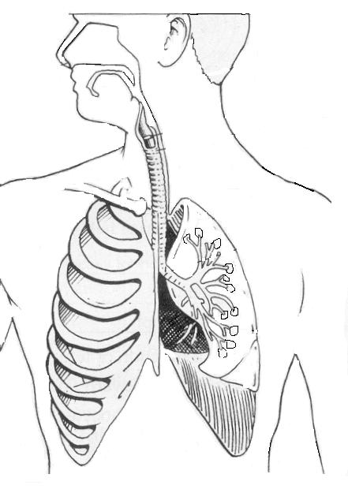

A

B

C

|  |  |  |
| --- | --- | --- |
| **Structure** | **Name of structure** | **Function** |
| A |  |  |
| B |  |  |
| C |  |  |

(3 marks)

(b) Examine the diagram below.

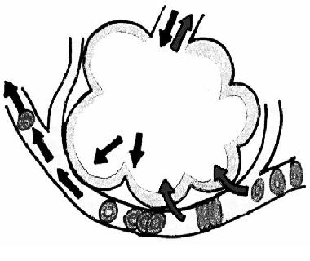

A: ________________________

B: ____________________________

1. Name structure A and B by writing in the space provided above. (2 marks)
2. What occurs between structures A and B? __________________________________________

(1 mark)

1. Explain how this occurs. You may add to the diagram and refer to this in your explanation.

__________________________________________________________________________________

__________________________________________________________________________________

__________________________________________________________________________________

__________________________________________________________________________________

__________________________________________________________________________________

__________________________________________________________________________________

(3 marks)

28. Lung capacity is measured by a simple breathing test using a spirometer. It measures the total amount of air that a person breathes in and out, giving an indication of lung capacity. Lung capacity is determined on many factors, but a person in good health will generally have a larger lung capacity than a person in poor health.

A study was conducted of the effects of exercise on lung capacity. Participants in the study were divided into two groups of nine. All participants were males aged between 18 and 30 years. Participants in group A were on an exercise program which involved regular running and swimming workouts. The participants in Group B were told not to change their daily physical activity from what they were already doing. Over a six-week period, the lung capacity of each participant was measured weekly with a spirometer and averaged for the groups. Shown below is a table of the results from the experiment.

|  |  |  |
| --- | --- | --- |
| **Time**  **(weeks)** | **Average lung capacity (litres)** | |
| **Group A** | **Group B** |
| 0 | 5.5 | 5.0 |
| 1 | 5.5 | 5.0 |
| 2 | 5.8 | 5.2 |
| 3 | 6.0 | 5.2 |
| 4 | 6.0 | 5.5 |
| 5 | 6.5 | 5.5 |
| 6 | 7.0 | 5.5 |

1. Propose a hypothesis for this experiment.

__________________________________________________________________________________

__________________________________________________________________________________

(1 mark)

(b) Identify:

(i) The independent variable: ___________________________________________________________

(1 mark)

(ii) The dependent variable: ____________________________________________________________

(1 mark)

(iii) Two variables that were controlled in the experiment:

__________________________________________________________________________________

__________________________________________________________________________________

(2 marks)

(c) If the researchers were aiming to improve the reliability of the experiment, suggest one change they could make to the experiment.

__________________________________________________________________________________

(1 mark)

(d) Further experiments were undertaken on different factors affecting lung capacity. What effect would you expect the lifestyle choice of smoking cigarettes would have on lung capacity? Justify your answer.

__________________________________________________________________________________

__________________________________________________________________________________

(2 marks)

29. Every cell in the human body is dependent on enzymes for its proper functioning.

(a)Name the type of enzyme that digests fats or lipids and state one place that it is produced.

__________________________________________________________________________________

__________________________________________________________________________________

(2 marks)

1. Name the substance produced in the liver that helps in the digestion of lipids and explain how it is different to an enzyme.

__________________________________________________________________________________

__________________________________________________________________________________

(2 marks)

30. During the process of digestion, large molecules are broken down into smaller, usable molecules by mechanical and chemical digestion. Bile assists in the process of digestion.

(a) Which large molecules does bile break down?

__________________________________________________________________________________

1. mark)

(b) Does bile break down this molecule mechanically or chemically?

__________________________________________________________________________________ (1 mark)

1. Where is bile produced?

__________________________________________________________________________________

(1 mark)

(d) Where is bile stored?

__________________________________________________________________________________

(1 mark)

31. Describe the features of the small intestine that maximise the process of absorption.

__________________________________________________________________________________

__________________________________________________________________________________

__________________________________________________________________________________

__________________________________________________________________________________

__________________________________________________________________________________

__________________________________________________________________________________

__________________________________________________________________________________

__________________________________________________________________________________

__________________________________________________________________________________

(4 marks)

32. Why are people who suffer from coeliac disease likely to become malnourished?

__________________________________________________________________________________

__________________________________________________________________________________

__________________________________________________________________________________

__________________________________________________________________________________

__________________________________________________________________________________

__________________________________________________________________________________

(3 marks)

**END OF TEST**